**HOMEWORK REQUIREMENTS**

Do the same for your Google Cloud Microinstance. That server should always be online (as it is a microinstance, it should be free and never impact your overall credits). That server will host your project webpage.

The Google server should have the following page:

1. An index page (landing page) that describes your overall project, including:
   1. A list of all the members of your team
   2. A description of your project
      1. Make sure the overview is appropriate for a grade school audience

Eventually, this will be updated with instructions for accessing/running your service.

**REPORT REQUIREMENTS**

**50 points total**

For your submission, you can copy and paste the following into a new document.

* [4 points] Copy and paste a **screenshot** of the default Apache webpage that you took in Step 1.1

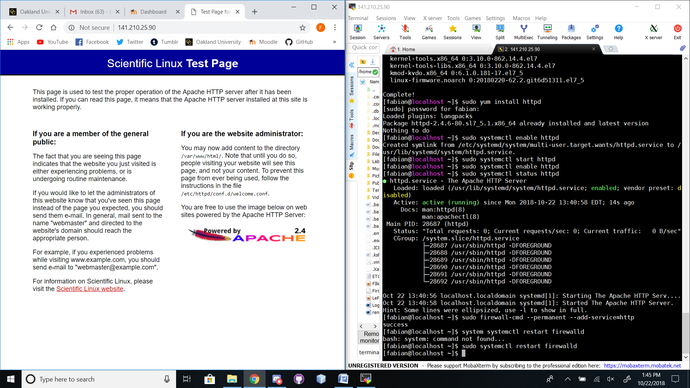

* [6 points] Why do you need to **start** and **enable** the **httpdservice?**

**I needed to do this so the http/Apache service would be running on the machine. This makes it so the microinstance has an External IP address that can be reached by my browser.**

* [6 points] Do a Google search (or look in your book) at the **firewall-cmd** command. What is the purpose of this command, and why do you need to run it?
* [3 points] Why do we need to run the **mysql_secure_installation** command after installing MySQL?
* [6 points] What are **two** differences between MariaDB and MySQL? Provide your source.
* [5 points] Place your screenshot of the PHP settings page here:

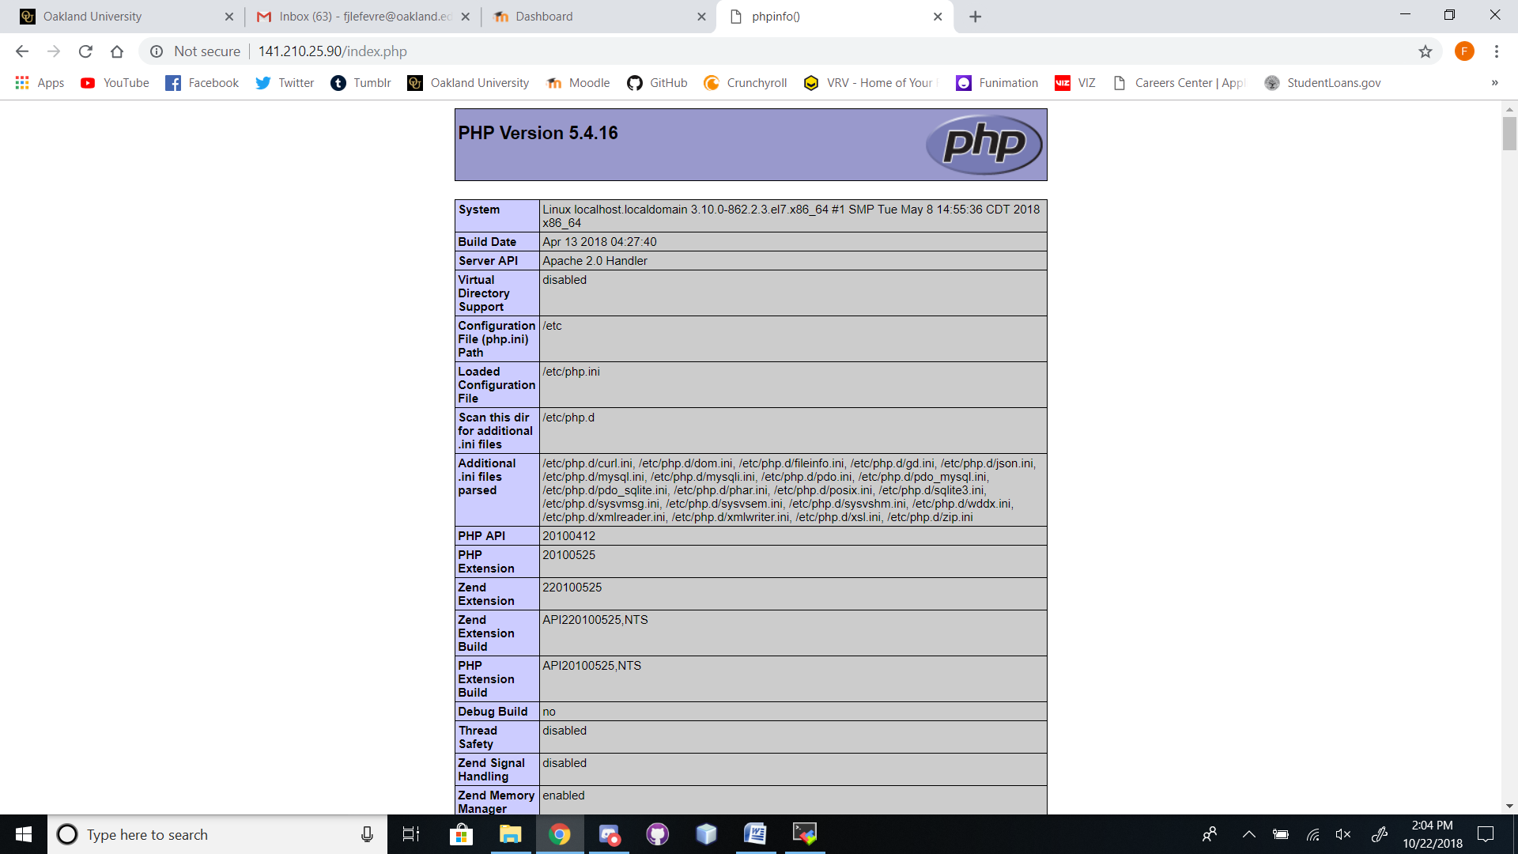

* [20 points] Provide the **external** IP address of your Google website and a screenshot of it.

**35.237.103.49**

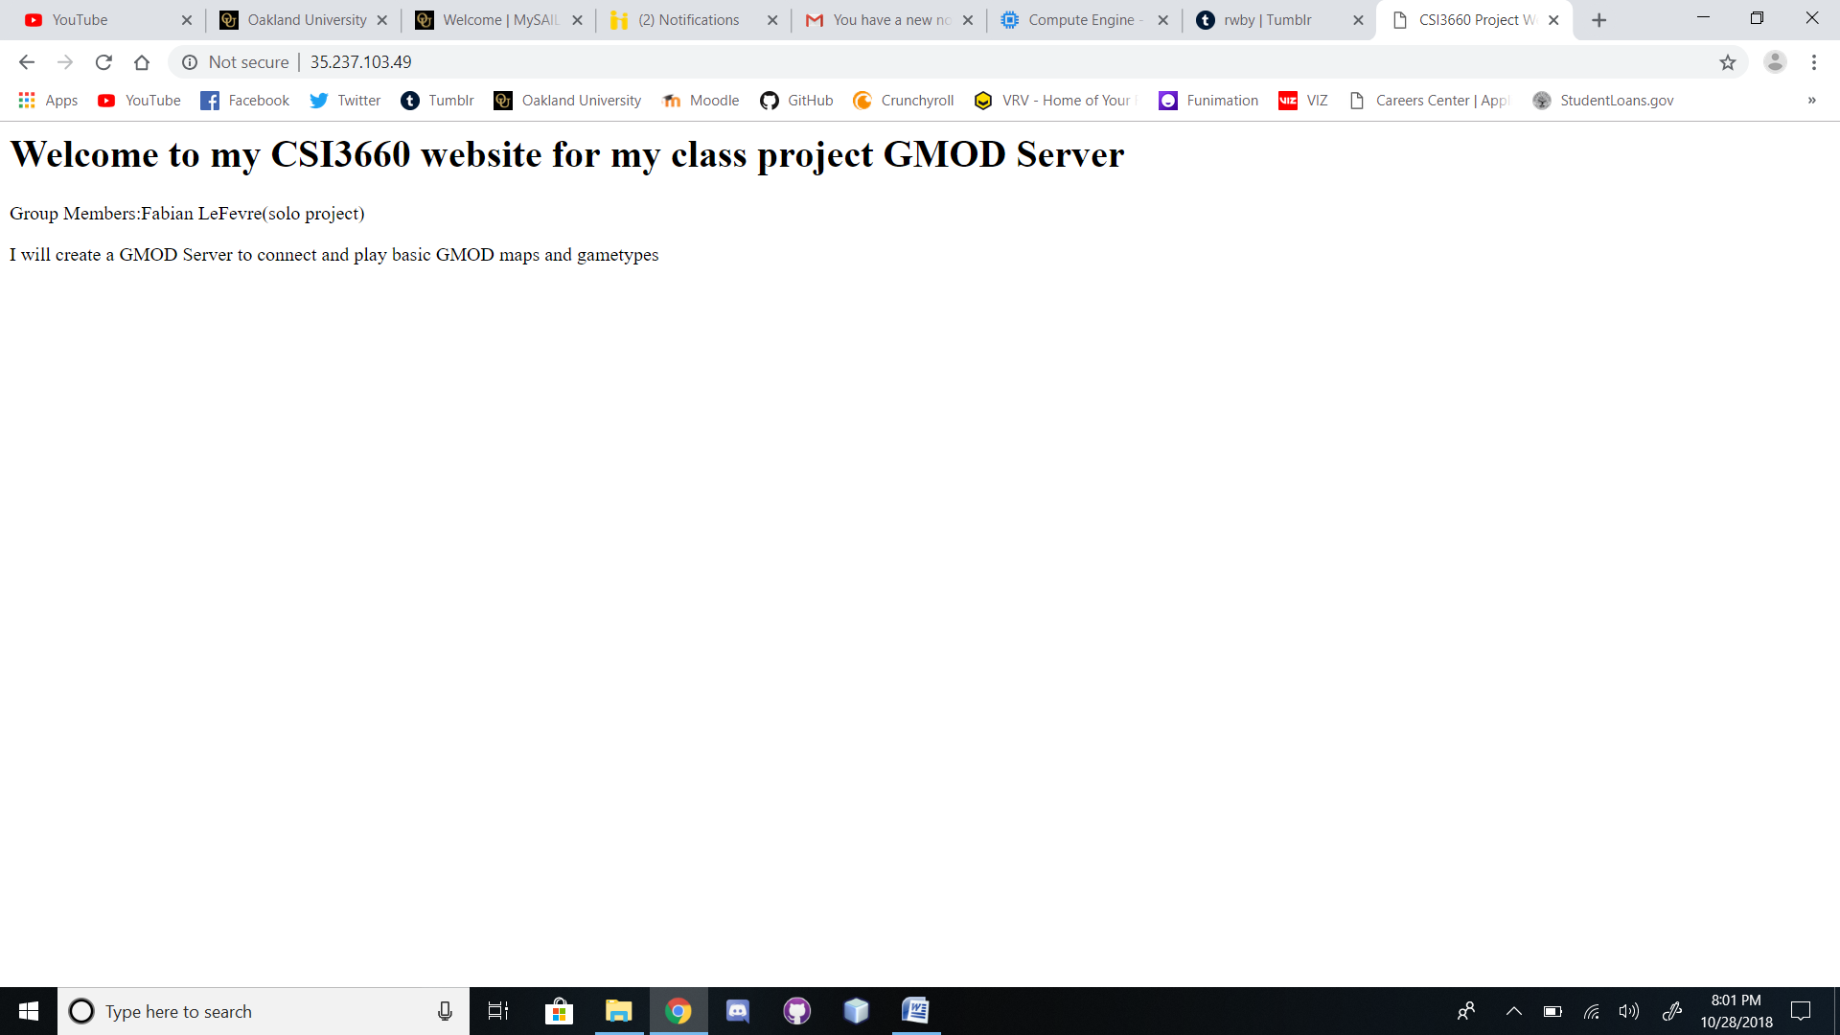

**Extra Credit:**

(10 points) Setup phpMyAdmin and demonstrate it working.